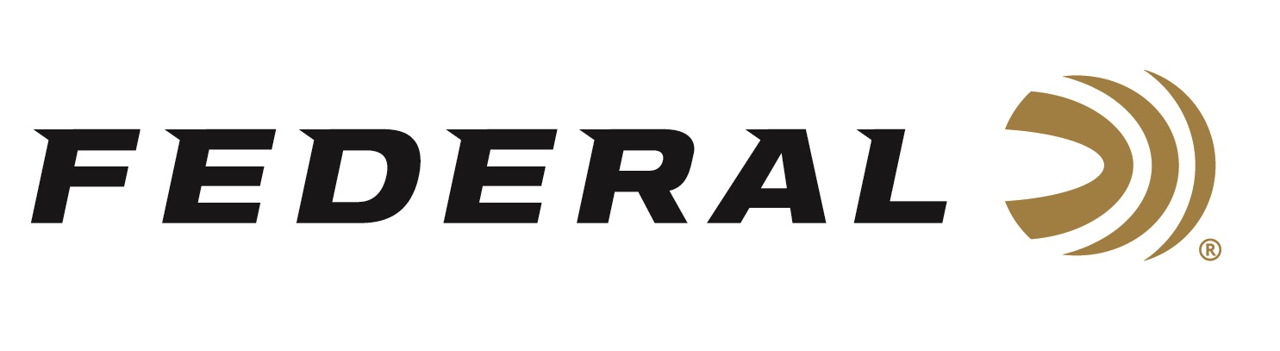

FOR IMMEDIATE RELEASE

Federal’s Sponsored Shooter Cameron Hicks Wins FITASC at Seminole Cup

ANOKA, Minnesota – March 3, 2026 – Federal Ammunition congratulates Cameron Hicks for his event winning performances at the recent Seminole Cup. The premier sporting clays competition took place at Broadfield, a Sea Island Sporting Club and Lodge in Georgia. The Seminole Cup kicked off on February 24 and concluded on March 1, 2026, with more than 600 shooters competing.

Hicks won two events at this year’s Seminole Cup including the EZGO Shootout Qualifier and FITASC. The victory over 205 shooters in FITASC had a special meaning for Hicks. “My dad won the same event in 2003, and I’ve gotten close a few times,” said Hicks. “I had to be perfect in the last and hardest parcour to get into a shoot off and then won it. Achieving this same victory brings a great sense of pride to have this father and son connection,” said Hicks.

Hicks used Federal’s new Master Class, a competition-level sporting clay load, to win both events at this year’s Seminole Cup. This is the second significant win at a popular sporting clay event utilizing Master Class. Hicks was also the winner of the 2025 Main Event High Over All at the Gamaliel Cup using Master Class. His winning load at this year’s Seminole Cup was the 12-ga., 1-ounce Master Class offering at 1300 fps in 7.5 shot.

Federal Ammunition products, including the new Master Class, are available at dealers nationwide and online. This competition-level sporting clay load features a customized Podium wad that extracts peak performance from utilizing Federal’s straight-wall hull, reliable primers, high-antimony lead shot, and select propellant. For more information on Master Class and all Federal products, visit www.federalpremium.com.

Learn more at: Master Class | Federal Premium

Federal Ammunition products are available at dealers nationwide and online. For more information on all Federal products and to sign up to receive notifications about new product availability, rebate promotions, and other brand news via email, visit www.federalpremium.com.

Press Release Contact: JJ Reich
Senior Manager – Press Relations
E-mail: media@tkghunt.com

About Federal Ammunition
Federal, headquartered in Anoka, MN, is an ammunition brand of The Kinetic Group, owned by CSG, a globally diversified industrial group based in Prague, Czech Republic. Since 1922, Federal has been a leader in ammunition innovation, delivering high-quality sporting and hunting products to shooters worldwide. With a commitment to conservation and the outdoor community, Federal continues to manufacture industry-leading ammunition that enhances the shooting experience while supporting outdoor traditions.

